Puritans’ Beliefs about Children

In “The Great Care of Godley Parents: Early Childhood in Puritan New England,” Gerald Moran and Maris Vinovskis write,

No aspect of New England theology has been more damaging to the historical reputation of Puritan treatment of childhood than the doctrine of infant damnation. Historians have asked, How could the Puritans have loved their children and at the same time have consigned deceased infants to eternal damnation? In theory, all infants and children who died unconverted suffered the eternal torments of hell. Since few infants were thought to experience conversion, this meant that the great majority of deceased infants were considered damned (Stannard, 1977, p. 49). The awful fate awaiting children at their demise was magnified in the minds of Puritans by their depiction of hell as a place of unremitting and unmitigated torment and horror.

The reality of Puritans’ beliefs about children’s innocence or corruption was significantly more complicated, as you will see from the documents in this packet. Puritans had particular beliefs about childhood and, like any parents, expectations and hopes for their children.

Your task today is to take a stand on this question: To what extent did Puritan parents believe in the doctrine of infant damnation?

Document #1: Anne Bradstreet’s letter to her children

To my Dear Children
Anne Bradstreet, 1612-1672

Original Source: The Works of Anne Bradstreet in Prose and Verse. Edited by John Harvard Ellis. (Charlestown: A. E. Cutter, 1867)

THIS Book by Any yet unread,
I leave for you when I am dead,
That, being gone, here you may find
What was your liveing mother's mind.
Make use of what I leave in Love
And God shall blesse you from above.
A. B.

My dear children,–

I, KNOWING by experience that the exhortations of parents take most effect when the speakers leave to speak, and those especially sink deepest which are spoke latest– and being ignorant whether on my death bed I shall have opportunity to speak to any of you, much lesse to All– thought it the best, whilst I was able to compose some short matters, (for what else to call them I know not) and bequeath to you, that when I am no more with you, yet I may bee dayly in your remembrance, (Although that is the least in my aim in what I now doe) but that you may gain some spiritual Advantage by my experience. I have not studyed in this you read to show my skill, but to declare the Truth– not to sett forth myself, but the Glory of God. If I had minded the former, it had been perhaps better pleasing to you,– but seing the last is the best, let it bee best pleasing to you.

The method I will observe shall be this– I will begin with God's dealing with me from my childhood to this Day. In my young years, about 6 or 7 as I take it, I began to make conscience of my wayes, and what I knew was sinfull, as lying, disobedience to Parents, &c. I avoided it. If at any time I was overtaken with the like evills, it was as a great Trouble. I could not be at rest 'till by prayer I had confest it unto God. I was also troubled at the neglect of Private Dutyes, tho: too often tardy that way. I also found much comfort in reading the Scriptures, especially those places I thought most concerned my Condition, and as I grew to have more understanding, so the more solace I took in them.

In a long fit of sickness which I had on my bed I often communed with my heart, and made my supplication to the most High who sett me free from that affliction.

But as I grew up to bee about 14 or 15 I found my heart more carnall, and sitting loose from God, vanity and the follyes of youth take hold of me.

About 16, the Lord laid his hand sore upon me and smott mee with the small pox. When I was in my affliction, I besought the Lord, and confessed my Pride and Vanity and he was entreated of me, and again restored me. But I rendered not to him according to the benefitt received.

After a short time I changed my condition and was marryed, and came into this Country, where I found a new world and new manners, at which my heart rose. But after I was convinced it was the way of God, I submitted to it and joined to the church at Boston.

After some time I fell into a lingering sickness like a consumption, together with a lamenesse, which correction I saw the Lord sent to humble and try me and doe mee Good: and it was not altogether ineffectual.

It pleased God to keep me a long time without a child, which was a great greif to me, and cost mee many prayers and tears before I obtaind one, and after him gave mee many more, of whom I now take the care, that as I have brought you into the world, and with great paines, weaknes, cares, and feares brought you to this, I now travail in birth again of you till Christ bee formed in you.

Among all my experiences of God's gratious Dealings with me, I have constantly observed this, that he hath never suffered me long to sitt loose from him, but by one affliction or other hath made me look home, and search what was amisse – so usually thus it hath been with me that I have no sooner felt my heart out of order, but I have expected correction for it, which most commonly hath been upon my own person, in sicknesse, weaknes, paines, sometimes on my soul, in Doubts and feares of God's displeasure, and my sincerity towards him, sometimes he hath smott a child with a sicknes, sometimes chasstened by losses in estate, – and these Times (thro: his great mercy) have been the times of my greatest Getting and Advantage, yea I have found them the Times when the Lord hath manifested the most Love to me. Then have I gone to searching, and have said with David, Lord search me and try me, see what wayes of wickednes are in me, and lead me in the way everlasting: and seldome or never but I have found either some sin I lay under which God would have reformed, or some duty neglected which he would have performed. And by his help I have layd Vowes and Bonds upon my Soul to perform his righteous commands.

If at any time you are chastened of God, take it as thankfully and Joyfully as in greatest mercyes, for if yee bee his yee shall reap the greatest benefitt by it. It hath been no small support to me in times of Darknes when the Almighty hath hid his face from me, that yet I have had abundance of sweetness and refreshment after affliction, and more circumspection in my walking after I have been afflicted. I have been with God like an untoward child, that no longer than the rod has been on my back (or at least in sight) but I have been apt to forgett him and myself too. Before I was afflicted I went astray, but now I keep thy statutes.

I have had great experience of God's hearing my Prayers, and returning comfortable Answers to me, either in granting the Thing I prayed for, or else in satissfying my mind without it; and I have been confident it hath been from him, because I have found my heart through his goodnes enlarged in Thankfulnes to him.

I have often been perplexed that I have not found that constant Joy in my Pilgrimage and refreshing which I supposed most of the servants of God have; although he hath not left me altogether without the wittnes of his holy spirit, who hath oft given mee his word and sett to his Seal that it shall bee well with me. I have sometimes tasted of that hidden Manna that the world knowes not, and have sett up my Ebenezer, and have resolved with myself that against such a promis, such tasts of sweetnes, the Gates of Hell shall never prevail. Yet have I many Times sinkings and droopings, and not enjoyed that felicity that somtimes I have done. But when I have been in darkness and seen no light, yet have I desired to stay myself upon the Lord.

And, when I have been in sickness and pain, I have thought if the Lord would but lift up the light of his Countenance upon me, altho: he ground me to powder, it would bee but light to me; yea, oft have I thought were it hell itself, and could there find the Love of God toward me, it would bee a Heaven. And, could I have been in Heaven without the Love of God, it would have been a Hell to me; for, in Truth, it is the absence and presence of God that makes Heaven or Hell.

Many times hath Satan troubled me concerning the verity of the scriptures, many times by Atheisme how I could know whether there was a God; I never saw any miracles to confirm me, and those which I read of how did I know but they were feigned. That there is a God my Reason would soon tell me by the wondrous workes that I see, the vast frame of the Heaven and the Earth, the order of all things, night and day, Summer and Winter, Spring and Autumne, the dayly providing for this great houshold upon the Earth, the preserving and directing of All to its proper end. The consideration of these things would with amazement certainly resolve me that there is an Eternall Being.

But how should I know he is such a God as I worship in Trinity, and such a Saviour as I rely upon? tho: this hath thousands of Times been suggested to mee, yet God hath helped me over. I have argued thus with myself. That there is a God I see. If ever this God hath revealed himself, it must bee in his word, and this must bee it or none. Have I not found that operation by it that no humane Invention can work upon the Soul? hath not Judgments befallen Diverse who have scorned and contemd it? hath it not been preserved thro: All Ages maugre all the heathen Tyrants and all of the enemyes who have opposed it? Is there any story but that which showes the beginnings of Times, and how the world came to bee as wee see? Doe wee not know the prophecyes in it fullfilled which could not have been so long foretold by any but God himself?

When I have gott over this Block, then have I another putt in my way, That admitt this bee the true God whom wee worship, and that bee his word, yet why may not the Popish Religion bee the right? They have the same God, the same Christ, the same word: they only enterprett it one way, wee another.

This hath somtimes stuck with me, and more it would, but the vain fooleries that are in their Religion, together with their lying miracles and cruell persecutions of the Saints, which admitt were they as they terme them, yet not so to bee dealt withall.

The consideration of these things and many the like would soon turn me to my own Religion again.

But some new Troubles I have had since the world has been filled with Blasphemy, and Sectaries, and some who have been accounted sincere Christians have been carryed away with them, that somtimes I have said, Is there ffaith upon the earth? and I have not known what to think. But then I have remembred the words of Christ that so it must bee, and that, if it were possible, the very elect should bee deceived. Behold, saith our Saviour, I have told you before. That hath stayed my heart, and I can now say, Return, O my Soul, to thy Rest, upon this Rock Christ Jesus will I build my faith; and, if I perish, I perish. But I know all the Powers of Hell shall never prevail against it. I know whom I have trusted, and whom I have beleived, and that he is able to keep that I have committed to his charge.

Now to the King, Immortall, Eternall, and invisible, the only wise God, bee Honoure and Glory for ever and ever! Amen.

This was written in much sicknesse and weaknes, and is very weakly and imperfectly done; but, if you can pick any Benefitt out of it, it is the marke which I aimed at.

Document #2: Selected poems of Anne Bradstreet

Before the Birth of One of Her Children

All things within this fading world hath end,
Adversity doth still our joys attend;
No ties so strong, no friends so dear and sweet,
But with death's parting blow are sure to meet.
The sentence past is most irrevocable,
A common thing, yet oh, inevitable.
How soon, my Dear, death may my steps attend,
How soon't may be thy lot to lose thy friend,
We both are ignorant, yet love bids me
These farewell lines to recommend to thee,
That when the knot's untied that made us one,
I may seem thine, who in effect am none.
And if I see not half my days that's due,
What nature would, God grant to yours and you;
The many faults that well you know I have
Let be interred in my oblivious grave;
If any worth or virtue were in me,
Let that live freshly in thy memory
And when thou feel'st no grief, as I no harmes,
Yet love thy dead, who long lay in thine arms,
And when thy loss shall be repaid with gains
Look to my little babes, my dear remains.
And if thou love thyself, or loved'st me,
These O protect from stepdame's injury.
And if chance to thine eyes shall bring this verse,
With some sad sighs honor my absent hearse;
And kiss this paper for thy dear love's sake,
Who with salt tears this last farewell did take.

In Memory of My Dear Grandchild Elizabeth Bradstreet, Who Deceased August, 1665 Being a Year and a Half Old

Farewell dear babe, my heart's too much content,
Farewell sweet babe, the pleasure of mine eye,
Farewell fair flower that for a space was lent,
Then ta'en away unto eternity.
Blest babe why should I once bewail thy fate,
Or sigh the days so soon were terminate;
Sith thou art settle in an everlasting state.

By nature trees do rot when they are grown.
And plums and apples throughly ripe do fall,
And corn and grass are in their season mown,
And time brings down what is both strong and tall.
But plants new set to be eradicate,
And buds new blown, to have so short a date,
Is by His hand alone that guides nature and fate.

--Anne Bradstreet, 1665

On my dear Grand-child Simon Bradstreet, Who dyed on 16. Novemb. 1669. being but a moneth, and one day old

No sooner come, but gone, and fal'n asleep,
Acquaintance short, yet parting caus'd us weep,
Three flours, two searcely blown, the last i'th' bud,
Cropt by th'Almighties hand; yet is he good,
With dreadful awe before him let's be mute,
Such was his will, but why, let's not dispute,
With humble hearts and mouths put in the dust,
Let's say he's merciful as well as just.
He will return, and make up all our losses,
And smile again, after our bitter crosses.
Go pretty babe, go rest with Sisters twain
Among the blest in endless joyes remain.

Document #3: Headstones of Puritan Children

- Ichabod Ackley (1764, East Haddam, CT)
- Elizabeth Atwood (1703, Malden, MA)
- Benjamin Russell (1712/3, West Tisbury, MA)
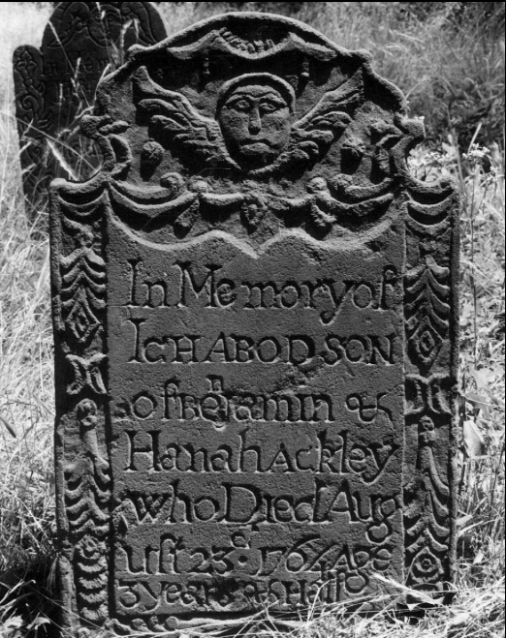
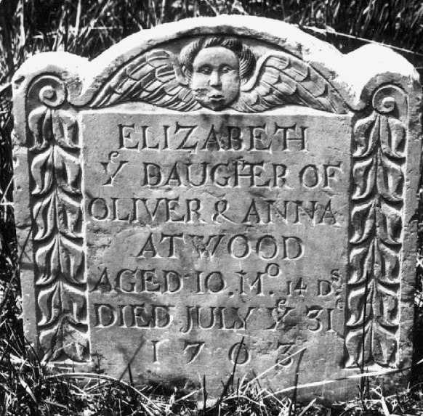

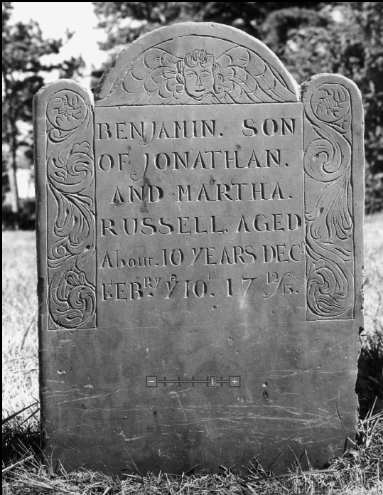

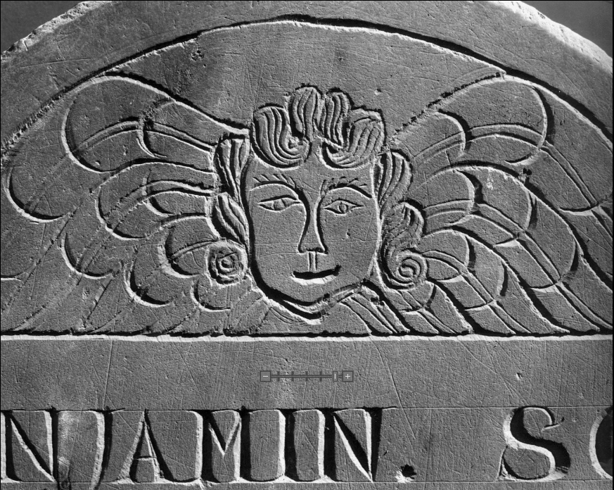

Document #4: Walking Stool

http://cdm.reed.edu/cdm4/item_viewer.php?CISOROOT=/colhist&CISOPTR=633&CISOBOX=1&REC=13

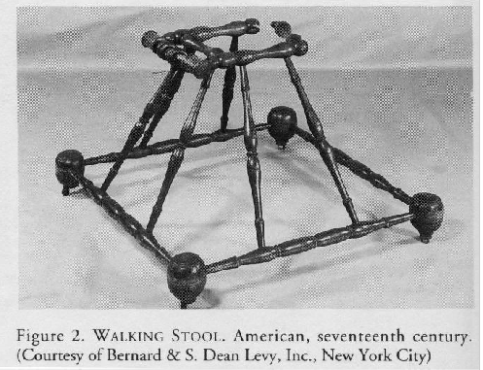

Document #5: Poem by Edward Taylor (ca. 1642-1729, Massachusetts)

Upon Wedlock, and Death of Children

Top of Form
1 A Curious Knot God made in Paradise,
2 And drew it out inamled neatly Fresh.
3 It was the True-Love Knot, more sweet than spice
4 And set with all the flowres of Graces dress.
5 Its Weddens Knot, that ne're can be unti'de.
6 No Alexanders Sword can it divide.
7 The slips here planted, gay and glorious grow:
8 Unless an Hellish breath do sindge their Plumes.
9 Here Primrose, Cowslips, Roses, Lilies blow
10 With Violets and Pinkes that voide perfumes.
11 Whose beautious leaves ore laid with Hony Dew.
12 And Chanting birds Cherp out sweet Musick true.
13 When in this Knot I planted was, my Stock
14 Soon knotted, and a manly flower out brake.
15 And after it my branch again did knot
16 Brought out another Flowre its sweet breath'd mate.
17 One knot gave one tother the tothers place.
18 Whence Checkling smiles fought in each others face.
19 But oh! a glorious hand from glory came
20 Guarded with Angells, soon did Crop this flowere
21 Which almost tore the root up of the same
22 At that unlookt for, Dolesome, darksome houre.
23 In Pray're to Christ perfum'de it did ascend,
24 And Angells bright did it to heaven tend.
25 But pausing on't, this sweet perfum'd my thought,
26 Christ would in Glory have a Flowre, Choice, Prime,
27 And having Choice, chose this my branch forth brought.
28 Lord, take't. I thanke thee, thou takst ought of mine,
29 It is my pledg in glory, part of mee
30 Is now in it, Lord, glorifi'de with thee.
31 But praying ore my branch, my branch did sprout
32 And bore another manly flower, and gay
33 And after that another, sweet brake out,
34 The which the former hand soon got away.
35 But oh! the tortures, Vomit, screechings, groans,
36 And six weeks fever would pierce hearts like stones.
37 Griefe o're doth flow: and nature fault would finde
38 Were not thy Will, my Spell, Charm, Joy, and Gem:
39 That as I said, I say, take, Lord, they're thine.
40 I piecemeale pass to Glory bright in them.
41 I joy, may I sweet Flowers for Glory breed,
42 Whether thou getst them green, or lets them seed.

Notes
2] inamled: enamelled.
5] Weddens: wedding.
14] a manly flower: Edward's son Samuel (born August 27, 1675).
16] another Flowre: Edward's daughter Elizabeth (born December 27, 1676, died
December 25, 1677).
17] tother: another (."the other.").
18] Checkling: chuckling.
31] ore: over.
32] another manly flower: Edward's son James (born October 12, 1678).
33] another, sweet: Edward's daughter Abigail (born August 6, 1681, died August 22,
1682).

Text: The Poems of Edward Taylor, ed. Donald E. Stanford with a forward by Louis L. Martz (New Haven: Yale University Press, 1960): 468-70. First published: The poetical works of Edward Taylor, ed. Thomas Johnson (New York: Rockland editions, 1939): 290-322.

Document #6: Rules of Dorchester Schools (1641)

74. Rules of Dorchester Schools
BY THE TOWN OF DORCHESTER (1641)

THE schoolmaster shall faithfully attend his school and do his best to benefit his scholars. In this he is to use his best judgment, and|not remain away from school unless necessary. This would be to the disadvantage of his scholars and would hinder their learning.
From the beginning of the first month until the end of the seventh, he shall begin to teach every day at seven of the clock in the morning. For the other five months he shall begin every day at eight of the clock in the morning and end at four in the afternoon.

Every day in the year the usual time for dismissing at noon shall be at eleven; to begin again at one.

But every second day of the week, he shall call his scholars together between twelve and one of the clock to examine them. This is to find out what they have learned the Sabbath day before. At this time he shall take notice of any wrong-doing or disorder that any of his scholars have committed on the Sabbath.
Then at some suitable time he shall instruct them how they must do at another time. Or he may punish them if the offence shall require it.

He shall equally and impartially teach such as are placed in his care. No matter whether their parents be poor or rich, he shall not refuse any who have a right and interest in the school.²⁴⁵

Such as are placed in his care he shall faithfully teach both in the regular school studies and also in points of good manners. He shall teach them dutiful behavior to all, especially those who are their superiors.

Every sixth day of the week²⁴⁶ he shall question his scholars in the principles of Christian religion.

All men's efforts, without the blessing of God must be fruitless and unsuccessful. Therefore it is to be a chief part of the schoolmaster's duty to commend his scholars and his work to God in prayer. This he shall do morning and evening, taking care that his scholars do devoutly listen during the prayer.

The rod of correction is a rule of-God necessary sometimes to be used upon children.²⁴⁷ It may easily be abused by too much severity or too much kindness. The schoolmaster shall have full power to punish all or any of his scholars, no matter who they are.

He shall do as the offence seems to require. All his scholars must be subject to this rule.

No parent or other person living in the place shall go about to hinder the master in this.

But if any parent or others shall think there is just cause for complaint against the master for too much severity, they shall have liberty to tell him so in friendly and loving way.
[245] This warning was necessary in a century when the richer and more influential men were always given the better places.
[246] That is, every Saturday.
[247] At that time parents and teachers frequently whipped their children with rods.

Document #7: Pages from The New England Primer (ca. 1687-90)

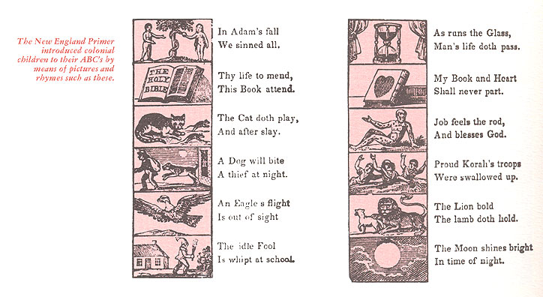
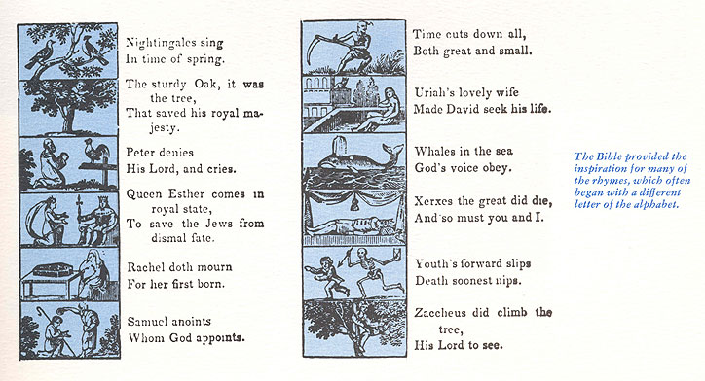

Gerald Moran and Maris Vinovskis. “The Great Care of Godley Parents: Early Childhood in Puritan New England,” Monographs of the Society for Research in Child Development 50, no. 4/5 (1985): 24-37, here p. 25. http://www.jstor.org/stable/3333861.

